Search Swagger Documentation

Orders Swagger Documentation

Customers Swagger Documentation

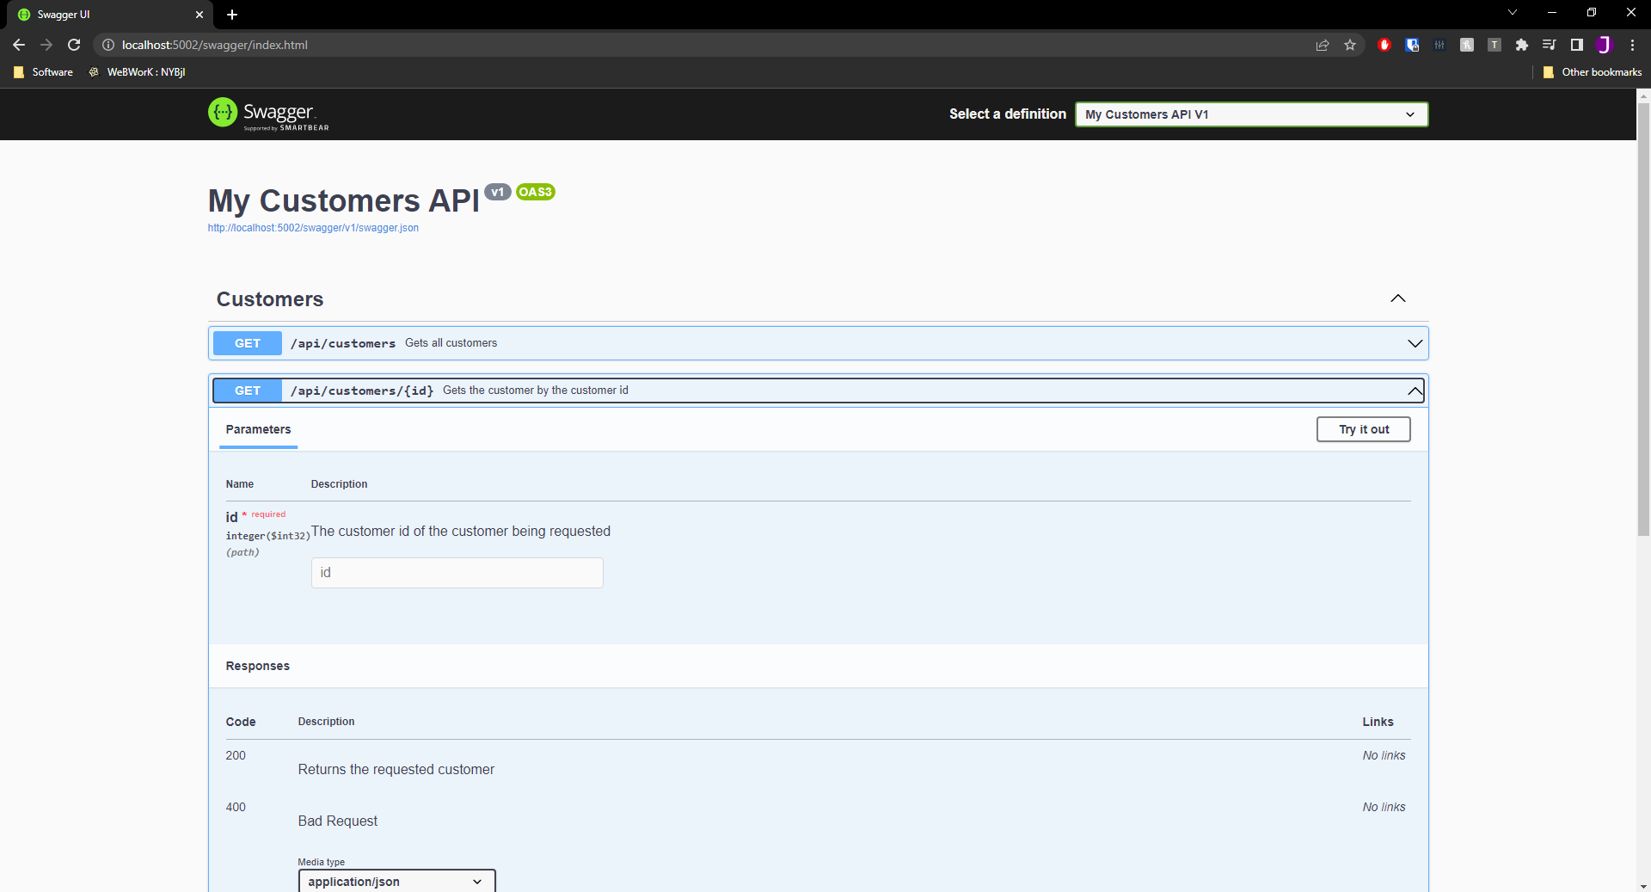

Products Swagger Documentation

